Governance Walkthrough

Thursday, June 24, 2021

3:29 PM

Attendees: Seun Mafi, Jason Nazare, Moriah Striegel, Saicharan Sirangi, Sol Vazquez, Saurabh Dilip Saxena, Raymond Cloutier, Oliva Lawson, Matthew Colville, Tyrell Jarett, Sonal Jain, Yogesh, Shinde, Aerozona Obiadazie.

**AGENDA:**

**Jason: Go over Data governance piece, and how CDR is involved, who the key stakeholders are, and how request are tracked.**

**Raymond:** For every release, we create a governance model. We capture the consumer data sources, data use polices, consent, and the gaps that exist in our framework.

**What are they using the data for?**

Machine generated alternative text:
klinical Domain Centric Governance Model 
Release 2. I 
Overview 
Thus document describes the data governance framework in place today which Will be used to 
data use policies for release 2.1 for: 
HAL Health Dashboard 
1. Capture Consumers use Case and Data Requirements 
HAL Health Dashboard — to enable viewing of immunization records. Details 
regarding this 
se and 
o Hal Case O uerview 
As we mature our consumer onboarding process, we will develop a form which enables 
cu"entlw spread documents in the above link. The form 
capturing and storing Of details 
will include (but not limited to) the following items: 
Consumer Data Needs 
Historic Data requirements and sources 
PHIR 
Patient Consent Enforcement 
Access Method (API/ analytics) 
Access Frequency 
SLA 
2. New Data Source Ingest 
Data ingestion is handled by the EDP — CDR team. 
There is a standard form for on premise data ingestion request which should be used for new data 
Sources. 

Data we are looking for include: Immunization, COVID Lab etc.

**Jason: Do we fill out the information or the consumer does?**

Raymond: We do.

A snapshot of what the patient will see when they register.

Machine generated alternative text:
Can 
pa S' West. RI 
City. SWe 
City, 
OIV • 19 
06-20 t 9 
PASTEUR 
B.072020 
City. SwO 

Use case:

Machine generated alternative text:
HEALTH FOR 
Vision: Ongoing Care and Support 
Evolving into a 360 view of the consumer, creating a lifetime relationship with consumers through compelling, 
Illustrative 
personalized digital health experiences 
snaring a 360 view or tne consumers realm record 
Managing tor tne tamity 
Bring them along 
28 
Making the health record actionable 
SVOS to 
*CVSHea1th. 
Note: Illustrative concepts pendi•g legal'brand input In all scenarios, the customer would have the option 
to control their account, any sharin$caregiver geferences, and all clinical and Othel information 

**Ray:** We also capture information they (patient) need for data that meets their need. We map our data from the data sources to where the data is stored. We talk about the file attributes and where the data came from. We track from source to target.

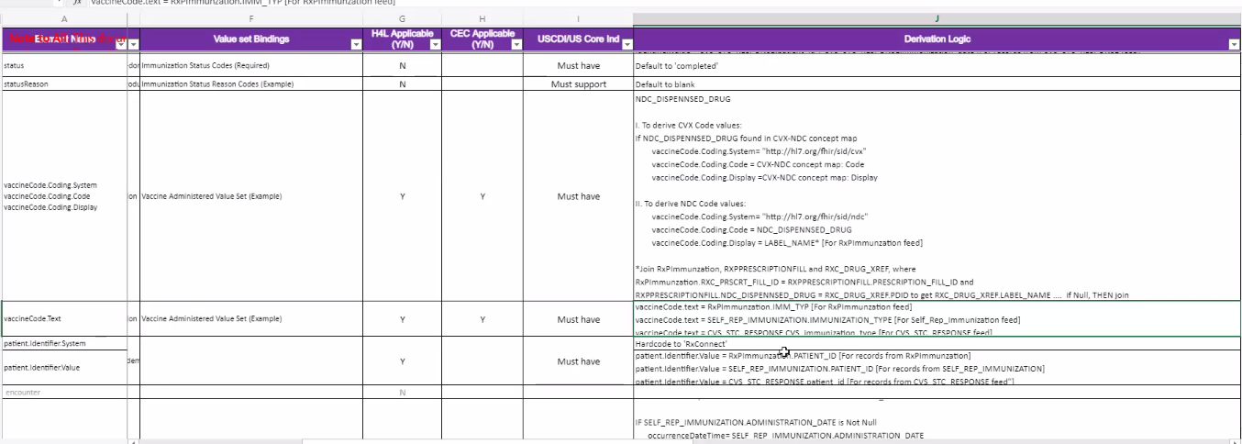

Currently they (Patients) are able to access immunization data from RXConnect.

**Ray:** We are currently mapping immunization data. The CIAR will call out the other data. In the future, they (Patients) will get medication data as well.

**Jason: Is there a defined time?**

**Ray**: Any consumer who wants to use data from CDR must complete a CIAR which is approved by Legal and compliance. Once approved, the lifespan of the CIAR is one year.

**Jason: Additional time?**

**Ray:** They can extend for one year I believe.

**Ray:** Here is what CIAR looks like. (See document) Will be provided in Auditboard.

**Jason: Is there a specific person that approves the data?**

**Yogesh:** That is handled by the data governance team. They will review and approve.

**Jason: Since the scope here is clinical data, it is coming through a single metric?**

**Ray**: After the CIAR is approved, comes back, then we write the data policy, make sure it is what we are asking for.

**Jason: Read somewhere there is plans of migrating to Archer?**

**Ray**: Yes. We don't have a timeframe. We can get back to you if its required information.

**Ray:** Here is the data use policy we approved.

Machine generated alternative text:
Digital - Hælth for Life 
Policy (e.g. Restricted Data Source, Restricted Data Fields. Restricted Data 
Timeframe) 
Data 
Policy ID 
Source 
1429042 Archer 
1429042 Archer 
1429042 Archer 
14290Z2 Archer 
1.1290Z2 Archer 
1429042 Archer 
1429042 Archer 
14290.2 Archer 
1429042 Archer 
Status 
Active 
Active 
Active 
Active 
Active 
Active 
Active 
Active 
Active 
Digital - Health for Life 
Digital - Health for Life 
Digital - Health for Life 
- Health for Life 
Digital - Health for Life 
Digital - Health for Life 
Digital 
- Health for Life 
Digital - Health for Life 
Digital 
- Health for Life 
Restricted Access 
sed on CIAR Expiration Date 
Restricted Access Based on Purpose of Use 
Restricted Access Based on Data Source (Provenance Resource) 
Restricted Access on Data Source (Provenance Resource) 
Restricted Access on Data Type (FHIR Resource) 
Restricted Access on Data Type (FHIR Resource) 
Restricted Access Based on Data Type (FHIR Resource) 
Restricted Access Based Data Fields - TED - pending input 
Restricted Access Based on Data Timeframe 
is permited ACCESS to CDR for RxConnect EPIC MinuteClinic Immunization and Mediaticms 
based on the expiration date of the CIAR (Expiration Oate of CIAR Approval 12/22/2022) 
HAL is restricted access to data where the purpose of use Treatment 
HdL is restricted to receiving data from RxCOnnect (CVS/Phgrmaey Data) thriNgh CDR. (Note: HIL 
collects patent consent to grant access to RxConnect data) 
H4L is restricted to receiving data from EPIC (MinuteCIinic Data) through CDR. (Note: H4L collects 
_oetient consent to 8rant accss to EPIC 
is restricted to the Patent resource 
is restricted to the Immunization 
HAL is restricted to the Lab resource 
is restricted to the lib data detailed in the "HAL permitted Lab Data Fields' tab 
HAL is restricted to a rolling S years of RxConnect immunization data (e.g. 7/15/2016 - 7/15/2021) 
Cuer Page Data use Policy H4L Consent rules 
H4L Permitted Imz Data Fields 
H4L Permitted Lab Data Fields 

They can only utilize data that has a treatment source. If a patient does not give consent, they cannot provide information. We have other consumers coming onboard that do not require consent. We are only entitled to share consented data.

We get two types of consent. PHI, and we get opt out (Don't share my data for any purpose). We blend in the health 4 life.

The only time we don't share data is when help4life has not gotten consent.

Machine generated alternative text:
HAL PHI disclosure 
CE opt in/out 
Out 
S out 
6 out 
(EPIC) PHI disclosure 
(EPIC) 
H4L PHI disclosure 
COR must share data 
CDR must not share date 
CDR must share data 
CDR must 
E_ COR must share data 
CDR must NOT shire data 
The PHI disclosure supercedes the EPIC CE opt th EPIC PHI disclosure and hart correction fVg_ 
14 

We are partnering with CCE for future use case.

**Bryan:**

Machine generated alternative text:
'h 
COR-os-Oöo 
COR-os-003 EPIC 
onent 
d stA 
Patna or ovidgrs 
data) 
Legal and Contractual 
WA (m BÅtCh 
trans tom ec 
I tm GCS. 
intecrated 
F stveJ 
Epic Sensitive Codes 
eMaae'e•ne Menappan@CVSHeannc 
- MA-tin. ra 
Read Me 
Data Sources 
EPIC care 
Consumers 
Meta Data 
Caremark Sensitive Drug List 
P' MA Legislation Sensitive ICDIO Procedures 

We are building a data store and this info will be removed from Excel.

We capture statistics around the timeframe and the various loads.

**Jason: Are you doing this manual process or someone else is doing it?**

**Ray**: I'm not doing it, but team members are doing it.

**Jason: The profiling is doing initially to set up the quality rules.**

Yogesh: When it goes into production live, it is monitored. Possible test cases are done before. Files get placed in the landing zone then it is moved.

EDP team and their framework lands data in our GCP landing bracket.

**Gaps in the framework** - We can schedule a different time to go over this information.